## NATIONAL AI DAY

## **What Is AI?**

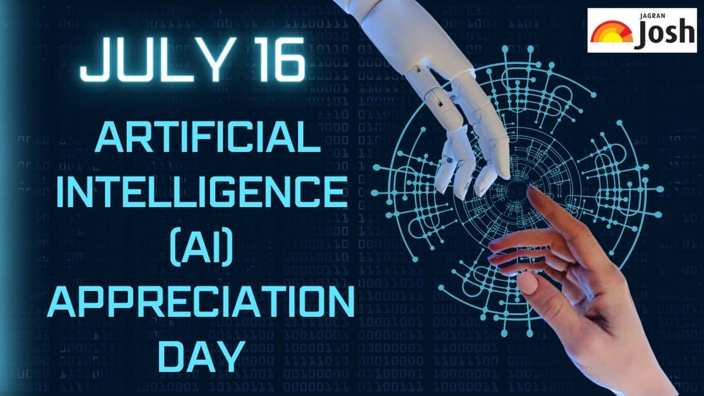Before we dive into AI’s function in the education space, let’s define this technology in general terms. Artificial intelligence allows machines to execute tasks that have traditionally required human cognition. AI-powered programs and devices can make decisions, solve problems, understand and mimic natural language and learn from unstructured data.

OpenAI’s release of ChatGPT—a natural language processing chatbot—in the fall of 2022 brought AI to many people’s attention for the first time. However, AI tools have been part of the tech landscape for years. If you’ve ever played chess against a bot, consulted a virtual assistant like Siri or Alexa or even scrolled through your social media feed, you’ve already interacted with artificial intelligence.

## **What Are the Functions of AI in Education?**

We’re still learning how AI technologies will integrate into the education sector as they develop, and we don’t yet have a full picture of how AI will affect critical issues of ethics, equity and data safety. However, we’ve already pinpointed several key uses for artificial intelligence in education, including the following.

### **AI-Powered Educational Games**The AI Era: A Bold Future that Transcends Conventions - Express Computer

Teachers have long recognized the value of play-based learning, and schools have used educational computer games—such as The Oregon Trail, first released in 1974—since the early days of computer gaming. Today’s AI-powered games can deliver targeted learning thanks to user-responsive programming.

### Adaptive Learning Platforms

Educational technology leaders such as Carnegie Learning and Knewton offer adaptive platforms that customize learning activities and content in real time. Continuous assessment allows for immediate feedback and helps the system adjust its approach. Adaptive learning methodologies vary from simple rules-based systems to multifaceted machine learning algorithms.

### **Automated Grading and Feedback Systems**Harnessing the Power of Artificial Intelligence in Computer Software Assurance for Life Sciences

By automating grading, planning and administrative work, artificial intelligence systems can free up educators’ time and energy for increased student contact. This is a common argument in support of using AI in the classroom.

### **Chatbots for Student Support**

At many higher education institutions, university chatbots support learners by responding to admissions queries, connecting students to course information and student services and delivering reminders. Other chatbots can help students brainstorm ideas, improve their writing skills and optimize their study time.

### Intelligent Tutoring Systems

Often dedicated to a single subject such as math or language, intelligent tutoring systems simulate the one-on-one experience of working with a human tutor. Examples include the Duolingo app and Khan Academy’s Khanmigo tutoring system.

## **AI’s Influence on Education**

## Impact of Artificial Intelligence on Education